

**The UK economy and the world economy**

Speech given by

Ben Broadbent, External Member of the Monetary Policy Committee, Bank of England

The Institute of Economic Affairs State of the Economy Conference, London 26 February 2014

I am grateful to Alina Barnett, David Barkshire and Lukasz Rachel for assistance in preparing this speech, and also to other colleagues for helpful comments. The views expressed are my own and do not necessarily reflect those of the Bank of England or other members of the Monetary Policy Committee.

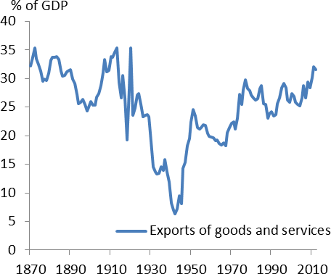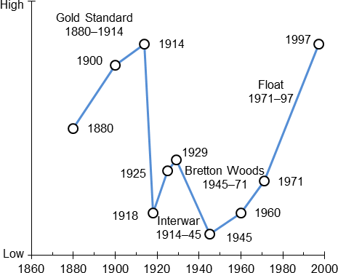We are often told we live in an era of unprecedented globalisation. But the UK has always been an open economy. The share of traded goods and services in GDP, at around 30%, is no higher today than it was 150 years ago (Chart 1). Chart 2, taken from Obstfeld and Taylor (2005), is a stylised representation of the degree of openness in global capital markets. It has a similar U-shaped pattern: the globalisation of the past fifty years has served mostly to recover ground lost during the first half of the last century1.

|  |  |
| --- | --- |
| **Chart 1: UK no more open than 150 years ago** | **Chart 2: Not the first era of open capital markets** |
| Source: Hills,Thomas, Dimsdale (2010) for data until 1949 and ONS for data between 1949 and 2012. | Source: Obstfeld and Taylor (2005), “Introspection” |

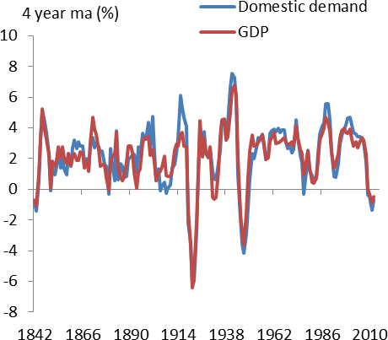Despite this long history, it seems to me that the public discourse about our economy tends to focus disproportionately on domestic considerations, domestic policy in particular.

|  |  |
| --- | --- |
| **Chart 3: Domestic demand “explains” most year-to-year growth in aggregate demand** | To a degree this is understandable. In principle, a floating exchange rate means UK inflation is ultimately under the control of the domestic monetary authority, regardless of how other central banks behave. On the real side, the standard accounting breakdown shows that, from year to year, movements in aggregate demand are dominated by its domestic components (Chart 3 depicts four-year averages of annual growth in GDP and domestic demand): changes in net trade are relatively small.  Over the longer run, economies can quite happily follow different “trend” rates of growth for years. There is also a wide variation in levels of (per-capita)  income across countries. |
| Source: Hills,Thomas, Dimsdale (2010) for data until 1949 and ONS for data between 1949 and 2012 |

1 Volosovych (2011) constructs a quantitative measure of capital market openness and claims it has more of a “J” than a “U” shape, but the point remains that it is likely to have fallen prior to the second world war and risen since.

These are correlated, economists have found, with underlying features of national economies – the integrity of contracts and property rights, for example, or the extent and quality of education – that, while not policy choices in the conventional sense, are nonetheless amenable to change. Clearly, therefore, we are far from powerless to determine our economic fortunes.

However, there’s still a risk that, even after the experience of a financial crisis that was so clearly global in nature, we under-appreciate the consequences of living in a global economy. This morning I want to make of couple of points in this regard, one about the short run – the cyclical horizon over which shifts in demand matter more for output – the other about productivity and our economic performance over the longer run. In doing so I cannot possibly claim to do any sort of justice to the vast literature in this area – it’s called open economy macroeconomics – and these points are as much about simple statistics as they are about economics. But they may still be worth bearing in mind.

## Correlated cycles

The first point is that, over the cycle, the contribution of trade to aggregate demand is a poor measure of the influence of global shocks on the UK economy. This is important because, at least in the simpler approaches to forecasting, variations in net trade seem to be the only way the rest of the world gets a look in. Short-run movements in output are assumed to be determined entirely by shifts in aggregate demand; domestic spending – consumption plus investment plus government spending – is in turn assumed to depend only on home-grown things (including domestic policy); to the extent it matters at all, the rest of the world influences domestic output growth purely via its demand for UK exports.

But this can’t be right because, in general, domestic demand here is strongly correlated with that in the rest of the world: Chart 4 depicts their annual growth rates since 1960. Because our economy is relatively small, this co-movement can only arise from the influence on our economy of shocks from elsewhere – or, at least, common to the UK and the rest of the world – not from things that originate at home. Chart 5 plots a rolling estimate of the same correlation going back to the late 19th century. Note that the opening (or rather the

re-opening) of international trade and capital flows during the second half of the last century saw the degree of co-movement go up. If the rebirth of globalisation has increased the coherence of national cycles, it’s done so by affecting all areas of spending, not just export demand.

Why might this be? Clearly, there are such things as global economic shocks. World wars, big political events, shifts in the supply of oil – these are all things that can affect domestic spending in many countries in a similar fashion. At least among developed countries, the same goes for bouts of technological progress, a topic I’ll return to below.

|  |  |
| --- | --- |
| **Chart 4: UK, world domestic demand correlated** | **Chart 5: Correlation has risen over time** |
| Source: Hills,Thomas, Dimsdale (2010), and Penn World Tables 7.1 | Source: Hills,Thomas, Dimsdale (2010), The Conference Board, and Penn World Tables 7.1  Note: World domestic demand pre-1960 calculated as world  GDP + UK trade balance, the latter valued at $ PPP prices. |

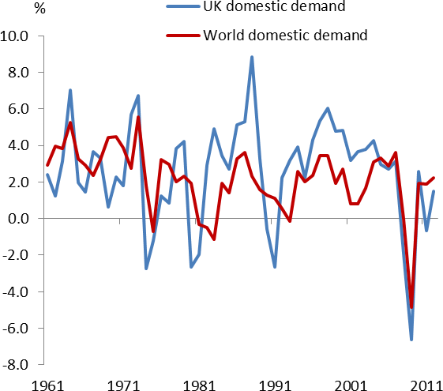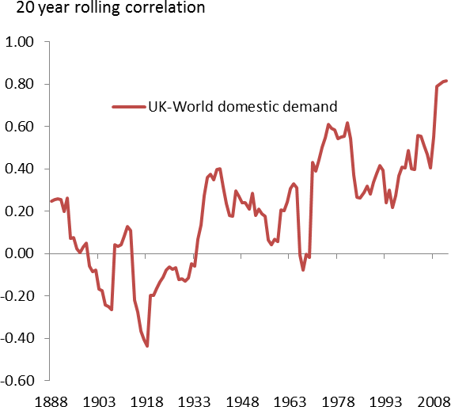But there’s no evidence the importance of these things has increased over time: if anything, the opposite is true2. A more likely explanation of the trend in Chart 5 is the rising degree of openness in global capital markets identified in Chart 2. As it’s become more integrated, the international financial system has become better at sharing, and distributing, economic shocks, thereby increasing the degree of co-ordination between economies, their domestic demand included.

You can see both good and bad in this. The good is that country-specific risks get shared. By selling development rights to foreign companies, for example, a commodity-rich nation can spread some of the underlying revenue risk to shareholders of those companies3. Pharmaceutical firms concentrate research projects with uncertain outcomes in particular countries, including this one, but raise money from across the world. The fact that a mortgage provider in California can sell default risk to an investor in London or Frankfurt is, at least in principle, a good thing. By diversifying country-specific risks in this way, the international financial system reduces their impact on national economies. As that system expands, you’d therefore expect precisely the rising degree of cyclical co-ordination evident in Chart 5.

As that last example illustrates, however, the potential bad is that the international financial system doesn’t just spread risk but creates and amplifies it too. The rapid expansion in the market for US mortgage-backed securities may have diversified exposure to default but, by increasing the distance between the ultimate

2 Per unit of output, oil consumption in the developed world is less than half what it was fifty years ago. As far as wars are concerned, the bare number of bilateral conflicts has increased since 1950. But so, by a greater margin, has the number of states. The per-period probability of war for any single state, and the number of deaths in armed conflicts, have both declined (Hewitt et al. (2012)).

3 If they are also consumers of those commodities, the shareholders would also benefit, as they get to hedge their real income exposure to volatility in the price of their commodity.

borrowers and lenders – informationally as well as geographically – it also seemed to increase the risk of it. In many instances, the final owner of US mortgage debt was both over-leveraged and ill-informed about the quality of the underlying asset. As I explained in a speech a couple of years ago, the significant majority of UK banks’ losses were made on their (very large) overseas balance sheets, not on their domestic lending. In the case of mortgages, for example, British banks lost £15 on their exposure to non-UK loans for every £1 lost at home.

Even in normal times, you can find plenty of evidence that financial conditions in the UK are susceptible to global developments. Take Chart 6. It plots the average response of 2-year and 10-year sterling interest rates to surprises in economic data. As you’d expect, news about UK GDP has a significant effect on interest rates at the front end of the curve. But similar (one-standard-deviation) surprises in US employment, which has no direct bearing on UK monetary policy, have almost as big an impact on 2-year rates and a much bigger impact at the long end of the sterling curve than any indicator of UK economic activity, including our own employment release. More generally, risk and term premia in equity and bond markets are much more tightly correlated across countries than the “fundamentals” would lead one to expect4.

In a well-publicised paper last year, the economist Helene Rey said these swings in risk sentiment had led to a “global credit cycle” that, for many countries, had little to do with their own economic conditions and was therefore destabilising. The cycle was instead, she said, driven disproportionately by developments in “the centre country” (the United States). Whatever their origin, it’s easy to see how such shifts in risk sentiment could induce co-movements in national cycles5. Because they add rather than subtract risk, these swings in risk sentiment would clearly be a less benign source of correlation than the diversification effects discussed above.

4 Shiller (1979) demonstrated that, at least over the sample period he used, corporate earnings were too stable to justify on their own the volatility of share prices. Campbell and Shiller (1991) established the same result for the relative variances of long bond yields and short-term interest rates. In both cases, the “excess volatility” of longer-dated security yields is correlated across countries (Dahlquist and Hasseltoft (2013)).

5 The reference is Rey (2013). Her specific point was that one of the key drivers of these swings in global financial conditions was US

monetary policy. But this wouldn’t necessary induce a positive cross-country correlation in domestic demand: indeed one could imagine its doing the opposite. Suppose domestic spending began autonomously to accelerate in the United States and that the Fed began to tighten monetary policy in response. Given the lags involved this could offset the original demand impulse only imperfectly, so US growth would remain stronger than it had been for some time. But global financial inter-linkages would, on the Rey view, lead to an unwarranted tightening in financial conditions in other countries and slower growth in domestic demand outside the US. To produce a positive correlation, therefore, there would have to be other things to which US monetary policy responded (swings in domestic costs, for example) and/or other sources of variation in global risk premia.

|  |  |
| --- | --- |
| **Chart 6: UK rates sensitive to US payrolls release** | **Chart 7: UK equity prices closely correlated6 with Euro Area sovereign spreads** |
| Source: Bloomberg and own calculations; sample 2003-13 | Source: Thomson Reuters Datastream, BoE calculations |

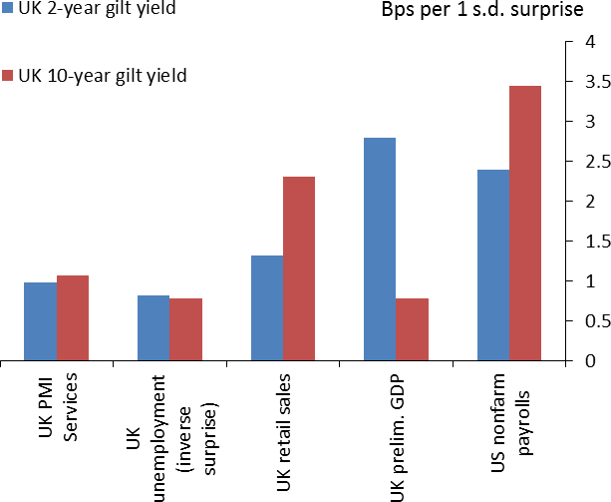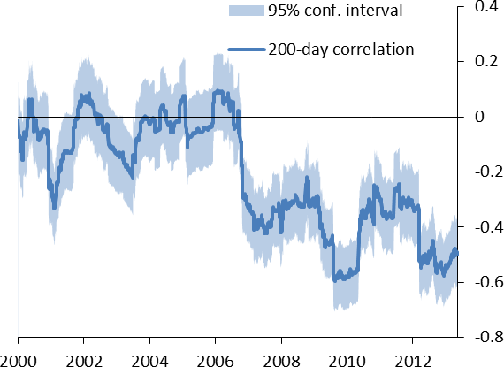The Rey paper has frequently been cited by emerging-market policymakers worried about the impact that the slowing rate of asset purchases by the US Fed – so-called “tapering” – has had on their own borrowing costs. But it’s easy to exaggerate this channel. It’s not as if the US is the only source of risk in the world – in the past 3-4 years, the problems in continental Europe have surely been more important, both globally and for UK markets specifically (Chart 7 plots the rolling correlation between daily moves in UK equity yields and the spread between periphery and core-country sovereign bond yields in the euro area).

The idea that the international financial system has done nothing but add risk – whatever its origin – is also at odds with the longer-term data. If that were true then, as that system grew, one would presumably have expected national economies to have become progressively more volatile over time. Yet, even allowing for the effects of the financial crisis, the variance of UK GDP growth over the past 20 years isn’t much higher than over any other 20-year period in our history; there’s certainly no upward trend in the series (Chart 8)7.

In any event, my main intention in this section is not to persuade you that global banks and capital markets are an unqualified “good” or “bad” thing, simply that they increase the inter-dependence of our economies. Together with the existence of economic disturbances that are truly global, an integrated financial system means the impact of world on the UK economy goes far beyond its demand for our exports. I’ll end this section by presenting a simple estimate of the true “global component” of UK growth. Derived by Bank economists, the blue swathe in Chart 9 is what you get (more or less) when you project UK growth on a

6 The correlation is between daily changes in sovereign spreads and the FTSE all share index, where the former is difference between 10-year German bond yield and a weighted-average 10-year yield for Greece, Ireland, Italy, Portugal and Spain.

7 The same is true of the variance of world GDP growth. Focusing on US data Dynan et al. (2006) argue that financial innovation helped to reduce the volatility of GDP growth in that country. Goldberg (2009) discusses the importance of globalisation of the banking system

specifically for risk-sharing and, as I go on to discuss in the next section, technology transfer. Kalemli-Ozcan et al (2013) present evidence from a wider range of countries that financial globalisation has increased the synchronisation of national cycles.

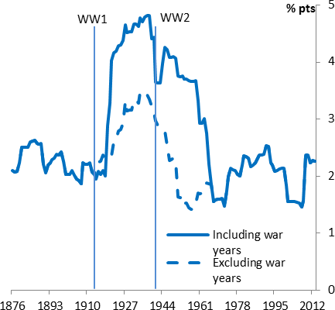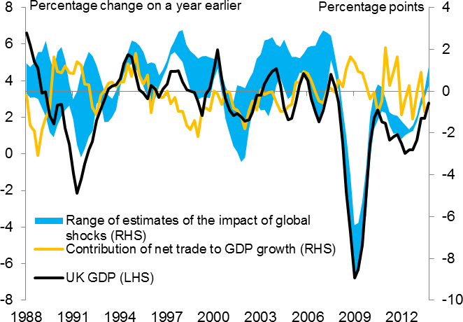range of world variables, financial as well as real. There are clearly times when international factors do not explain what’s happened in the UK. Though it was similar to that in the United States, for example, our own cycle of the late 1980s and early 1990s was completely out of synch with that in continental Europe. Driven by German re-unification, domestic demand in what is now the euro area began to accelerate at exactly the time the UK was entering recession; the aftermath of the re-unification boom, during which European growth then slowed, coincided with the post-EMU recovery in this country. In general, however, the blue swathe explains much more of UK growth than simple variations in trade volumes.

|  |  |
| --- | --- |
| **Chart 8: Variability of UK GDP growth no higher than long-run average** | **Chart 9: Influence of rest of world much more than movements in trade volumes** |
| Source: Hills,Thomas, Dimsdale (2010) and ONS Note: 20-year rolling window. | Source: Datastream and Bank of England calculations  Note: Swathe represents a range of central estimates from four variants of a structural VAR model.8 |

## Openness and relative productivity

This tells us something about the relationship between UK and global growth over the cycle. I now want to say something about the comparative behaviour of the UK economy over the longer run, at horizons over which activity depends more on supply, and trends in productivity, than on demand.

8 The estimates of the impact of global shocks (innovations to global demand and world prices, and global financial shocks) are obtained from four variants of a structural VAR model. The four variants employ different identification and estimation techniques over a sample period covering 1988Q1-2013Q4. Further analysis of these results and a more detailed description of the modelling approach will be published in a forthcoming Quarterly Bulletin article by Chowla, Quaglietti and Rachel (2014Q2)

|  |  |
| --- | --- |
| **Chart 10: UK productivity re-converged towards US levels from 1970-95, has diverged since crisis** | As you know, UK productivity growth has been unusually weak since the crisis – what output growth we’ve had has required a much bigger increase in employment than anyone expected. The UK isn’t alone in this respect: to varying degrees the same is true of many other countries in Europe. But one thing the slowdown has meant is a significant widening of the gap between  output-per-worker here and in the most productive large economy, the United States. Relative to that in the US, productivity in the UK fell by almost 10% between 2007 and 2012, the largest shortfall over any five-year period since the 1940s (Chart 10). |
| Source: Maddison (2007) and The Conference Board Note: UK and US GDP are in EKS PPP US$. |  |

That post-war period marked the high point for the gap between the two countries. Right up until the late 1960s, productivity in the UK was only around 60% of US levels. It then started to improve, steadily

re-converging to the technological “frontier”. By the mid-1990s the UK was just over 80% as productive as the US. The stagnation of the past five years, during which that figure has slipped to 74%, therefore represents a significant retreat.

I don’t want to imply this has happened specifically because of the contraction in international capital flows since the crisis9 nor, more generally, should one overdo the importance of openness for domestic productivity. But it is striking that the shape of the line in Chart 10 has the same U-shape as the measures of globalisation I showed you at the start. The long decline in the UK’s relative economic performance happened to coincide with the contraction in international trade and capital flows during the first half of the twentieth century. As these markets re-opened, the gap began to close again.

Can this just be co-incidence? There are certainly reasons for believing it might be more than that. There is other evidence, across a much wider range of countries, and controlling for other influences on growth, that greater openness allows faster convergence towards the productivity frontier10. There are also plausible reasons *why* this might be the case. Open capital markets allow countries to tap sources of finance other than their own saving. So to the extent productivity is low because an economy is under-capitalised, open markets should help. It’s also possible that international investment – direct investment in particular – brings with it more intangible benefits, including the underlying knowledge and ideas that drive productivity

9 I’ve suggested in other speeches that problems in the domestic financial system have contributed to the weakness of productivity growth but it’s likely that there’ve been several causes.

10 Baltabaev (2012), Cameron et al. (2005) and Giles and Stroomer (2003)

performance. Several studies have found that multinational firms are more productive than their domestic counterparts. Others posit that, over time, these embodied skills often spread to purely domestic companies in the same sector.

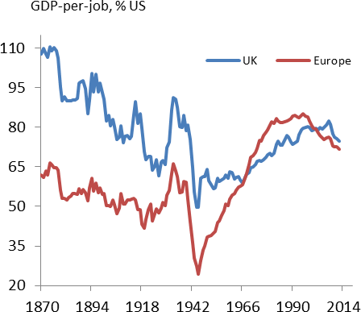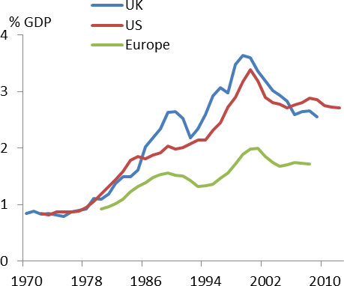The evidence for these wider benefits of FDI investment – “knowledge spillovers” – is more mixed, perhaps because they require certain things of the host country that may or may not be fulfilled11. In a well-cited study in 2007, for example, economists at the LSE found that US multinationals located in this and other European countries were significantly better at employing IT technology than their domestic counterparts. They also found that companies taken over by US firms saw significant improvements in this respect. But there was no evidence of some more general “spillover” to local companies. The study concluded that the full exploitation of these new technologies might require managerial expertise that, so far, companies in Europe had failed to develop. That in turn may be why, at a macroeconomic level, many European economies had failed to see either the same rates of IT investment as the US, or the same IT-driven acceleration in productivity in the from the early 1990s (Charts 11 and 12).

|  |  |
| --- | --- |
| **Chart 11: Euro area productivity growth fell below US rates long before the crisis** | **Chart 12: May be related to returns on ICT** |
| Source: Maddison (2007) and The Conference Board | Source: EU Klems and the Federal Reserve Board Note: “Europe” = EMU4 + Austria, Finland. |

That experience serves as a salutary lesson for the UK and, in particular, the view expressed in the latest MPC minutes that because “the technological frontier was still advancing globally… there was scope for the United Kingdom to take advantage of that as a source of higher productivity”. The decline in relative productivity in the euro area began several years before the financial crisis and there is no guarantee that our own productivity will again begin to converge to US levels, even as the international financial system

11 There is now a very substantial literature on the interaction between FDI and productivity. Das (1987) and Dasgupta (2012) are contributions to the theory, explaining why the effect should exist in principle. Papers testing for an unconditional spillover from FDI to the productivity of indigenous firms include Aitken and Harrison (1999), who find no effect, and Liu (2008), who does. Studies allowing for the possibility that the strength of any spillover depends on local factors include Borensztein (1998) and Alfaro et al (2009). The LSE study referred to in the text is Bloom et al. (2012).

returns to health. But I suspect that process – and, more generally, our openness to the rest of the world – is and will remain an important determinant of our long-run economic performance.

## Summary and conclusion

Let me try and summarise these points. As we’ve seen, our weather isn’t the only thing we import from across the Atlantic. During the crisis British banks lost considerable sums on property-related loans in Ireland and the United States. This contributed significantly to their need to cut back on domestic lending and the subsequent economic downturn in the UK. Nor is it just the Atlantic from which the economic weather can come: as Chart 7 showed, the cost of equity in the UK has for some time been tightly correlated with risk sentiment in the euro area. Thanks to the deep integration of international banks and capital markets, problems that arise in one part of the world can rapidly arrive on our own shores. That may be why, as the system has become more integrated over time, economic cycles (including in domestic demand) have become more co-ordinated.

## Chart 13: UK’s net overseas asset position maintained despite cumulative deficits

**Chart 14: Banks’ funding costs also fell in other parts of Europe in 2012H2**

% GDP

40

30

20

10

0

-10

-20

-30

-40

-50

Cumulative current account, 1990-

Net international investment position (NIIP) NIIP (market value)

Initial FLS announcement

# bps 450

400

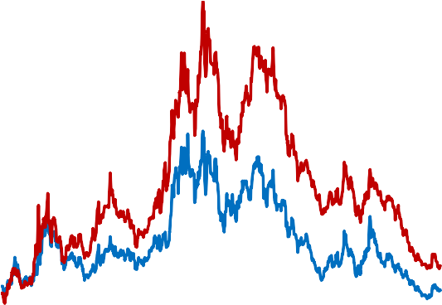

Draghi's speech

5 Year CDS UK

5 Year CDS EA

350

300

250

200

150

100

50

1990 1993 1996 1999 2002 2005 2008 2011

0

# 2010 2011 2012 2013 2014

Source: ONS and own calculations Source: Datastream

I believe it would be a big mistake, however, to imagine that the system brings us only problems. For one thing, that integration allows the UK to diversify its own domestic risks too. Around 40% of UK-quoted securities are owned by foreign investors, who will have absorbed a similar proportion of losses on those assets during the crisis. As it happens, the UK’s overseas assets have a relatively high proportion of equity and FDI and may therefore be slightly riskier than its collective overseas liabilities. But, to that extent, the average return on those assets is also likely to be higher. That’s probably why, despite cumulative current

account deficits of 40% of GDP over the past 20 years, the UK’s net overseas asset position hasn’t deteriorated (Chart 1312).

Second, the cyclical influence of the rest of the world can just as easily be positive as negative. Over the last year or so, for example, I think that receding near-term risk in the euro area has been a significant contributor to our own economic recovery. I’m not sure that’s the accepted view. Taking our flat trade balance as evidence that the rest of the world has failed to contribute anything to the recovery, most commentators point to purely domestic factors – the Funding for Lending Scheme, for example, or the government’s Help to Buy policy – as the primary cause of the recent acceleration in activity. The first of these was followed by a sharp retracement in the funding costs of UK banks, during the second half of 2012 (Chart 14). Following that drop, through the course of 2013, the supply of mortgage credit and housing-related economic activity both improved sharply.

There’s no doubt there was a link between these things: domestic policy was important in loosening the supply of domestic credit, and a good thing that has been. But UK policy alone cannot explain why, coincident with the fall in funding costs for UK banks, you also saw a steep decline in those for banks in continental Europe. That, surely, had more to do with the ECB’s declaration that it would “do whatever it takes” to hold the euro together, and the backing that statement received from core-country governments. Given their exposure to the euro area economies, the resulting improvement in risk sentiment will materially have benefited UK banks. There’s an important qualifier: had the European authorities not succeeded in bringing down risk premia in the second half of 2012, the FLS would have been that much more attractive to UK banks, relative to the costs of funding in the open market, and its impact on our economy that much larger. In other words, it has served partly as an insurance scheme, whose value is greater in bad times than in good. My only point about that episode, and about domestic cycles more generally, is that the international environment matters, and that it matters more than via trade volumes alone.

Finally, to return to the long run, I rather doubt that the UK would have enjoyed as rapid a convergence in productivity, towards US levels, had it not been for re-opening of international capital markets during the latter part of the last century. The inter-connectedness of global banking and capital markets probably contributed to the severity of the financial crisis. Since then, for one reason or another, UK productivity has stagnated and the earlier process of productivity convergence has gone into reverse. There’s no inevitability that we recover that lost ground: even when international capital is mobile, productivity can diverge as well as converge to the frontier. On balance, however, we are surely likely to benefit from our exposure to the world.

12 The red line in Chart 13 is the official ONS estimate of the UK’s net overseas asset position. The green line, estimated by Bank economists, attempts a more up-to-date valuation of FDI assets by using market prices of quoted equity.

## References

**Aitken, B. J., and A. E, Harrison**, 1999, “Do Domestic Firms Benefit from Direct Foreign Investment?”,

*American Economic Review*, 89(3), 605-618.

**Alfaro, L., S. Kalemli-Ozcan, and S. Sayek**, 2009, “FDI, Productivity and Financial Development”, *World Economy, 32*(1), 111-135.

**Baltabaev, B.,** 2012, “FDI and Total Factor Productivity Growth: New Macro Evidence”, Discussion paper 27/13, *Department of Economics*, Monash University.

**Bloom, N. R. Sadun, and J. Van Reenen**, 2012, "Americans Do IT Better: US Multinationals and the Productivity Miracle", *American Economic Review*, 102(1): 167-201.

**Borensztein, E., J. De Gregorio, and J. W. Lee**, 1998, “How does foreign direct investment affect economic growth?”, *Journal of International Economics, 45*(1), 115.

**Cameron, G., J. Proudman and S. Redding**, 2005, “Technological Convergence, R&D, Trade and Productivity Growth”, *European Economic Review*, 49(3), 775-807.

**Campbell, J. Y. and R. Shiller**, 1991, “Yield Spreads and Interest Rate Movements: A Bird's Eye View”,

*Review of Economic Studies*, 58(3), 495-514.

**Chowla,S., L. Quaglietti and L. Rachel**, 2014, “How have world shocks affected the UK? “ Bank of England, Quarterly Bulletin 2014 Q2, forthcoming.

**Dahlquist, M and H. Hasseltoft**, 2012, “International Bond Risk Premia”, Journal of International Finance, 90(1), 17-32.

**Das, S**., 1987, “Externalities and Technology Transfer through Multinational Corporations”, *Journal of International Economics, 22*(1/2), 171-182.

**Dasgupta, K**., 2012, “Learning and Knowledge Diffusion in a Global Economy”, *Journal of International Economics, 87*(2), 323-336.

[**Dynan,**](http://www.sciencedirect.com/science/article/pii/S0304393205001455) **K. E., D. W. Elmendorf and** [**D. E. Sichel**,](http://www.sciencedirect.com/science/article/pii/S0304393205001455) 2006, “Can Financial Innovation Help to Explain the Reduced Volatility of Economic Activity?”, Journal of Monetary Economics, 53(1), 123-150.

[**Fons-Rosen,**](http://www.nber.org/people/christian_fonsrosen) **C., S.** [**Kalemli-Ozcan,**](http://www.nber.org/people/sebnem_kalemli-ozcan) **B. E.** [**Sørensen,**](http://www.nber.org/people/bent_sorensen) [**C. Villegas-Sanchez**](http://www.nber.org/people/carolina_villegas-sanchez) **and** [**V. Volosovych**,](http://www.nber.org/people/vadym_volosovych) 2013, “Quantifying Productivity Gains from Foreign Investment”, NBER Working Paper No. 18920.

**Giles, E. A. and C. N. Stroomer**, 2003, “Does Trade Openness Affect the Speed of Output Convergence? Some Empirical Evidence”, Department of Economics, University of Victoria, Working Papers EWP0307.

**Goldberg, L.**, 2009, “Understanding Banking Sector Globalisation”, IMF Staff Papers 56, 171-197.

**Hills, S., R. Thomas and N. Dimsdale**, 2010, “The UK recession in context - what do three centuries of data tell us?”, Bank of England Quarterly Bulletin, 2010 Q4.

**Kalemli-Ozcan, S., E. Papaioannou and J Peydro**, 2013, “Financial Regulation, Financial Globalization, and the Synchronization of Economic Activity”, *The Journal of Finance*, DOI: 10.1111/jofi.12025.

**Liu, Z.**, 2008, “ Foreign direct investment and technology spillovers: Theory and evidence”, *Journal of Development Economics,* 85(1/2), 176-193.

**Maddison, A.,** 2007, “Contours of the World Economy 1-2030 AD”, Oxford University Press.

**Obstfeld, M. and A. M. Taylor**, 2005, “Global Capital Markets”, Cambridge University Press.

**Rey, H.,** 2013, “Dilemma not Trilemma: The Global Financial Cycle and Monetary Policy Independence”, Federal Reserve Bank of Kansas City, [Proceedings - Economic Policy Symposium - Jackson Hole.](http://ideas.repec.org/s/fip/fedkpr.html)

**Shiller, R. J**., 1979, “The Volatility of Long-Term Interest Rates and Expectations Models of the Term Structure”, *Journal of Political Economy*, 87(6), 1190-1219.

**Volosovych, V.,** 2011, “Measuring financial market integration over the long run: Is there a U-shape?”, Journal of International Money and Finance, 30(7), 1535-1561.